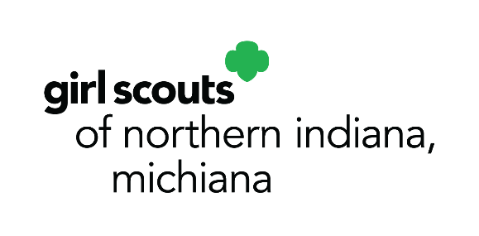

10008 Dupont Circle Drive East
Fort Wayne, IN 46825
p. 260.422.3417
800.283.4812
f. 855.422.0084
www.gsnim.org
August 17, 2021

Media Contact:
Faith Van Gilder, Chief Officer, Marketing & Development
O: 260.422.3417, Ext. 63138
C: 260.437.7583
faith.vangilder@gsnim.org

NEW ‘ADVENTUREFULS’ GIRL SCOUT COOKIE JOINS LINEUP FOR 2022 SEASON
(Fort Wayne, IN) – Today Girl Scouts of Northern Indiana-Michiana (GSNI-M) and Girl Scouts of the USA (GSUSA) announced that the new “Adventurefuls” cookie will join the nationwide lineup for the 2022 Girl Scout Cookie season. The brownie-inspired cookie with caramel-flavored crème and a hint of sea salt evokes the adventures Girl Scouts have through the organization.
Girl Scouts locally and across the United States will offer the Adventurefuls cookie next season alongside favorites like Thin Mints and Caramel deLites. Every cookie purchase, during cookie season, fuels local Girl Scouts’ adventures throughout the year: exploring what interests them, discovering their passions, and taking action on issues they care about. Whether they’re using their STEM skills to solve a problem, changing a law to help their community, having a courageous outdoor experience, or starting an innovative nonprofit, Girl Scouts build a better future for themselves and the world.
Through the Girl Scout Cookie Program, not only do girls become entrepreneurs as they gain hands-on experience running their own small business, but they also earn money to fuel their Girl Scout adventures, which catapult them where they want to go. Also new this year, GSUSA recently announced new Cookie Business badges that help girls think like entrepreneurs as they run their own cookie businesses and incorporate online sales. The badges progress from goal setting and effective sales-pitching in person and online to using market research, creating business plans, and implementing digital marketing campaigns.
For more information about GSNI-M, to join or volunteer, visit www.gsnim.org.
###
About Girl Scouts® and Girl Scouts of Northern Indiana-Michiana
Today, as when founded in 1912, Girl Scouts® helps cultivate values, social conscience and self-esteem in young girls, enabling them to succeed as leaders today and tomorrow. Girl Scouts of Northern Indiana-Michiana provides leadership experiences for over 4,500 girls ages 5-17. They are guided by more than 2,500 adult volunteers who mentor them and work behind-the-scenes to support Girl Scouts and our mission of building girls of courage, confidence, and character, who make the world a better place.

