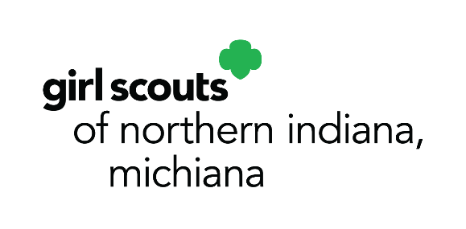

10008 Dupont Circle Drive East
Fort Wayne, IN 46825
p. 260.422.3417
800.283.4812
f. 855.422.0084
www.gsnim.org
October 1, 2021

Media Contact:
Faith Van Gilder, Chief Officer, Marketing & Development
O: 260.422.3417, Ext. 63138
C: 260.437.7583
faith.vangilder@gsnim.org

GIRL SCOUTS LAUNCH ANNUAL FALL PRODUCT PROGRAM TODAY

(Fort Wayne, IN) – Girl Scouts of Northern Indiana-Michiana (GSNI-M) today launched the fall product program, which will run through October 31. The annual program allows girls to be entrepreneurs by offering family and friends the opportunity to purchase delicious nuts, chocolates and magazines.

Girls will be taking orders both in-person and online. Customers can choose to have nuts, chocolates or magazines shipped directly to them, or they can select from a group of nut and chocolate products that girls can deliver. Items range in price from $6 to $10. New items this year include Sweet & Salty Mix, Nut & Seed Blend and Ruby Medley.

Customers may also participate in the “Care to Share” program, in which each $5 donation provides one can of nuts to our public service men and women.

During the month, girls will learn and practice the five skills of entrepreneurship: goal setting, decision making, money management, people skills and business ethics. All proceeds stay local to benefit the GSNI-M council, and troops earn start-up funds to use during the Girl Scout year to fund their various activities, trips and community service projects.

To get connected to a local Girl Scout troop, please contact frontdesk@gsnim.org or 1-800-283-4812.

To learn more about Girl Scouts and register, visit www.gsnim.org.
###
About Girl Scouts® and Girl Scouts of Northern Indiana-Michiana
Today, as when founded in 1912, Girl Scouts® helps cultivate values, social conscience and self-esteem in young girls, enabling them to succeed as leaders today and tomorrow. Girl Scouts of Northern Indiana-Michiana provides leadership experiences for over 4,500 girls ages 5-17. They are guided by more than 2,500 adult volunteers who mentor them and work behind-the-scenes to support Girl Scouts and our mission of building girls of courage, confidence, and character, who make the world a better place.

