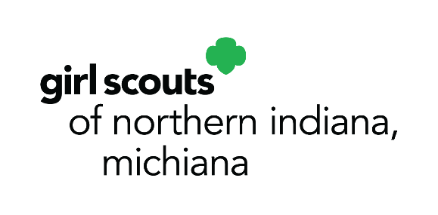

10008 Dupont Circle Drive East
Fort Wayne, IN 46825
p. 260.422.3417
800.283.4812
f. 855.422.0084
www.gsnim.org
August 3, 2021

Media Contact:
Faith Van Gilder, Chief Officer, Marketing & Development
O: 260.422.3417, Ext. 63138
C: 260.437.7583
faith.vangilder@gsnim.org

28 NEW BADGES EMBOLDEN GIRL SCOUTS TO NAVIGATE AND SUCCEED
IN A RAPIDLY CHANGING WORLD
Girl Scout badges for entrepreneurship, math in nature, and digital leadership build crucial skills and offer experiences that equip girls with the tools to build positive futures
(Fort Wayne, IN) – Girl Scouts of Northern Indiana-Michiana (GSNI-M) and Girl Scouts of the USA (GSUSA) today announced 28 new badges focused on entrepreneurship, math in nature and digital leadership that embolden girls to navigate a changing society and build the futures they want for themselves and the world. The new Girl Scout badges include:
- Math in Nature (grades K–5): These badges get girls outdoors to explore and conserve the natural world as they learn math concepts. Sponsored by Johnson & Johnson.
- Cookie Business (grades K–12): These badges help girls think like entrepreneurs as they run their own cookie businesses and incorporate online sales.
- Digital Leadership (grades K–12): Girl Scouts explore what a leader is, both online and in their everyday lives. They learn how to be online in a responsible and safe way, and dive into topics like managing their well-being online, how to balance their time on and offline, and more. Sponsored by Instagram.
“Girl Scouts helps girls cope with our changing world and build the futures they want to see,” said GSNI-M CEO Sharon Pohly. “Through these new badge activities, girls learn to conserve the natural world, run their own small business, create inspiring digital content and address cyber-bullying. Throughout the pandemic, Girl Scouts has been a source of connection, support and joy for girls, and we continue to address issues that girls, parents and caregivers care about.”
For more information about GSNI-M, to join or volunteer, visit www.gsnim.org.
###
About Girl Scouts® and Girl Scouts of Northern Indiana-Michiana
Today, as when founded in 1912, Girl Scouts® helps cultivate values, social conscience and self-esteem in young girls, enabling them to succeed as leaders today and tomorrow. Girl Scouts of Northern Indiana-Michiana provides leadership experiences for over 4,500 girls ages 5-17. They are guided by more than 2,500 adult volunteers who mentor them and work behind-the-scenes to support Girl Scouts and our mission of building girls of courage, confidence, and character, who make the world a better place.

