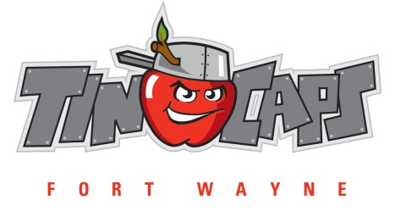

2021 Fort Wayne TinCaps Scout Campout Pizza Pre-Orders

The TinCaps will be offering pizzas for the overnight portion only on Friday, August 13th.

The TinCaps strongly encourage you to pre-order pizzas by the deadline of Wednesday, August 11th. You will save $2.00 per pizza and ensure that we have enough pizzas on hand for any game night orders.

ALL GAME NIGHT PIZZA ORDERS WILL BE $12.00 EACH AND MUST BE TURNED INTO GUEST SERVICES BY THE END OF THE 5TH INNING.

Return payment and order form to:
Fort Wayne TinCaps
Scout Pizza Orders
1301 Ewing Street
Fort Wayne, IN 46802

OR

Call Brenda Feasby at (260) 407-2809 or feasby@tincaps.com.

Pizza Type | Cost | # of Pizzas | Total
Cheese | $10.00
Pepperoni | $10.00
Supreme | $10.00
Total | ---

Method of Payment: Cash ________ Check ________

Visa ________ MasterCard ________ Discover ________

Card #: __ __ __ __ __ __ __ __ __ __ __ __ __ __ __ __

Expiration Date: __ __ / __ __ Three Digit # on back of card: __ __ __

Name of person who will
be picking up the pizza _____________________________________________________________________

