

This form is to be used by girls who are not in a troop who have participated in the Fall Product Programs and/or Girl Scout Cookie Programs who have earned program credits. Program credits can be used in any council store or trading post, any council activity or camp, any approved volunteer led event or camp, and approved expenses for Silver or Gold Awards. Program credits may only be used by the girl who earned them.

### Date Submitted: Amount of Request: $

**Source of Funds:** ❑ **Cookies $**

❑ **Fall product$**

### GSNI-M Staff must APPROVE ALL applications before release of product program funds.

For approval to access funds:

### Complete this form and submit at least 20 business days before funds are needed, as indicated below.

### Attach copies of pertinent documentation as indicated below.

* Program Credits must be requested prior to September 15 the year that they were earned.

Registered Girl Scout Name: ____________________________________________________

### Requested by: ________________________________ Daytime Phone:

### Address: ___________________________ City: ____________ State: ____ Zip Code:

Email address:

### Requesting funds for the following: *\*Note: Proper documentation is needed in order to process any requests.*

### GSNI-M Opportunities:

### ❑ Attach the Girl Leadership Activity (Program Event) registration form filled out for the event you want to attend

❑ Attach the completed **Camp registration form** for the camp you want to attend. Or a **Balance statement** if you want to use these funds to pay the balance of a camp you are already registered for.

### ❑ Girl Scout Membership Registration Fees (attach Membership Registration form)

❑ **GSNI-M Gift Card** (Can be used in any council store or trading post or for council events must be present to use, may not use on line. does not expire) **Amount:**

**Service Center to be picked up:**

❑ **Donation to GSNI-M** ❑General Fund ❑ Financial assistance fund; **Amount:**

❑ Other (Please specify)

### Opportunities where money needs to go outside of GSNI-M

### ❑ Girl Scout Community Event. Attach flyer/information about event and completed registration form. We will send payment and registration form directly to community event coordinator to register you for the event. Please allow 4 weeks before event deadline

### ❑ Silver or Gold Award Project. Please attach project plan (approved for gold), budget, and written request for reason for funds. Receipts will also be required.

### ❑ GSUSA Travel Opportunity. Attach confirmation of attendance and invoice. We will send payment directly to opportunity coordinator to pay on your balance. Please allow 4 weeks before payment deadline.

### 

### Please submit this form along with documentation to any GSNI-M Service Center or mail to GSNI-M LLC 10008 Dupont Circle Dr E, Fort Wayne, IN 46825,

**Or you may fax to 260-422-0084 or email it to frontdesk@gsnim.org**

|  |  |  |  |  |  |
| --- | --- | --- | --- | --- | --- |
|  | | |  |  | |
|  | | |  |  | |
| Parent/Guardian Date | | |  | GSNI-M Staff Date | |
|  | | | |
|  | | | |
|  | | | |
|  | | | |
|  | | | |

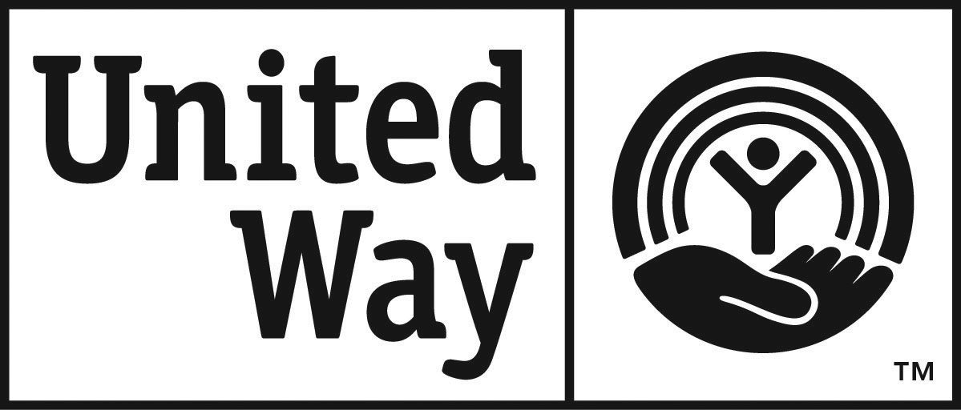

August 2005

Girl Scouts of Northern Indiana-Michiana  Product Manager   10008 Dupont Circle Dr E    Fort Wayne, IN 46825

(260) 422-3417  (800) 283-4812   Fax (260) 422-0084    www.gsnim.org